# EE511 week2 homework

# Zhang Fan USC ID: 1417-6851-15

**Q1. Simulate sampling uniformly (how many?) on the interval [-3,2].  
a. Generate a histogram of the outcomes.  
b. Compute the sample mean and sample variance for your samples. How do these values compare to the  
theoretical values? If you repeat the experiment will you compute a different sample mean or sample  
variance?  
c. Compute the bootstrap confidence interval (what width?) for the sample mean and sample standard  
deviation**

**Code:**

A=5*rand(1,10000)-3;

hist(A);%Q1(a)

Mean=mean(A)%mean

Variance=var(A)%variance

disp('Q1(c)confidence interval for sample mean: ')

Confidence_mean=bootstrp(10000,@mean,A);

x=sort(Confidence_mean);

ConMeanLow=x(250)

ConMeanHigh=x(10000-250)

disp('Q1(c)confidence interval for sample standard: ')

Confidence_std=bootstrp(10000,@std,A);

x=sort(Confidence_std);

ConStdLow=x(250)

ConStdHigh=x(10000-250)

**Results：**

Q1(a): Figure 1 shows that the data are evenly distributed by generating from rand function.

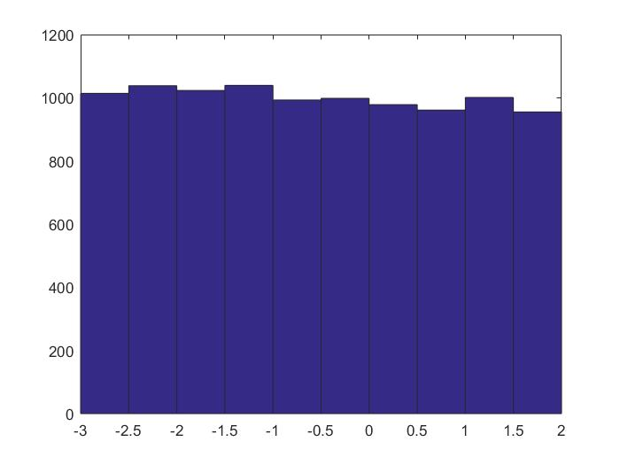

Figure 1: Generate a histogram of the outcomes [-3.2]

**Q1(b).**

**Simulation value:**

Mean =-0.5275

Variance = 2.0642

**Theory value:**

Mean: (-3+2)/5=0.2

Variance: ∑(xi-u)²=2.0833,

where xi is generated through

var(-3:0.00000001:2)

Yes, every time we have different data so that we will have different mean and variance. But they will not change a lot.

**Q1(c):confidence interval for sample mean: 95%**

ConMeanLow = -0.5556

ConMeanHigh =-0.4997

So we consider the data from [-0.5556, -0.4997] are convincing.

Q1(c)confidence interval **for sample standard**: 95%

ConStdLow =1.4237

ConStdHigh = 1.4492

So we consider the data from[1.4237,1.4492] are convincing.

Q2:

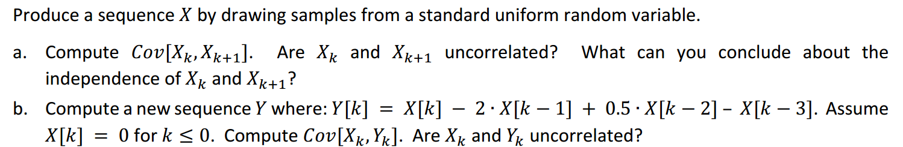

Code:

clear

disp('Q2(a)')%use

a=rand(1,1000);%

X_K=[a(1:end),0];%

X_K1=[0,a(1:end)];%

cov(X_K,X_K1,1);

coef=corrcoef(X_K,X_K1);%correlated coef

disp('Q2(b):')%use

XK=X_K;

XK1=[a(1:end),0];%

XK2=[a(2:end),0,0];%

XK3=[a(3:end),0,0,0];%

YK=XK-2*XK1+0.5*XK2-XK3;

corrcoef(YK,XK)

**result:**

Q2_a：

Cov[x_k,x_k+1]=[

0.0853 0.0023

0.0023 0.0853]

And their correlated coef is 0.0023 that can be approximate to 0. So x_k and x_k+1 don’t correlated.

The same as above, Cov[Y[K], X[K]]= [

0.1790 -0.0800

-0.0800 0.0853 ]

the correlated corf of Y[k] and X[K] are -0.6477. So they are almost correlated.

Discussion:

* We can find that the shift of the list data will greatly influence the correlatence.
* When Y[K] has a function with a X[K], these two lists will, absolutely have relatively highly correlated.

**Q3: Let M = 10. Simulate (uniform) sampling with replacement from the outcomes 0, 1, 2, 3, …, M‐1.  
a. Generate a histogram of the outcomes.  
b. Perform a statistical goodness‐of‐fit test to conclude at the 95% confidence level if your data fits samples  
from a discrete uniform distribution 0, 1, 2, …, 9.  
c. Repeat (b) to see if your data (the same data from b) instead fit an alternate uniform distribution 1, 2, 3,…, 10**

Code:

clear all;

test=floor(10*rand(1,10000));

hist(test)

test=hist(test);

test_theo = 1000*ones(1,10);

disp('Q3_1&2:')

ChisquaredTest = sum((test-test_theo).^2./test_theo);

ChisquaredThreshold_95 = chi2inv(0.95,10);%?? cdf??

sprintf('ChisquaredTest=%d\nChisquaredThreshold_95=%d\nReject?%d',...

ChisquaredTest,ChisquaredThreshold_95,ChisquaredTest>ChisquaredThreshold_95)

disp('Q3_3:')

test=[test(2:end),0];

ChisquaredTest = sum((test-test_theo).^2./test_theo);

ChisquaredThreshold_95 = chi2inv(0.95,10);%?? cdf??

sprintf('ChisquaredTest=%d\nChisquaredThreshold_95=%d\nReject?%d',...

ChisquaredTest,ChisquaredThreshold_95,ChisquaredTest>ChisquaredThreshold_95)

**Result:**

Q3_a: the figure shows that the data are evenly distributed.

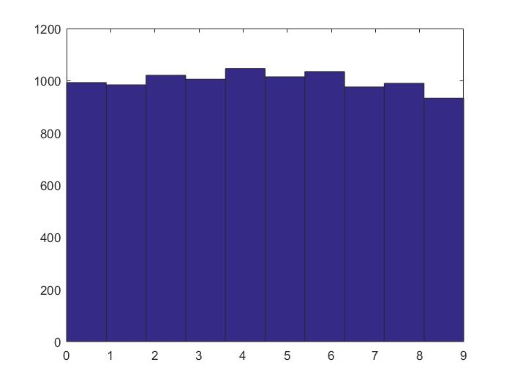

Figure 2: Generate a histogram of the outcomes of 0,1,2..9

Q3_b:

ChisquaredTest=9.606000e+00

ChisquaredThreshold_95=1.830704e+01

Reject?0

So the data fit the uniform distribution.

Q3_c:

ChisquaredTest=1.009557e+03

ChisquaredThreshold_95=1.830704e+01

Reject?1

So the data don’t fit the uniform distribution.